**Technical Stack : MEVN**

**Task**: you need to make a pixel-perfect layout of one of our widgets (we have a lot) that shows reactivations and renewals of subscriptions through time.

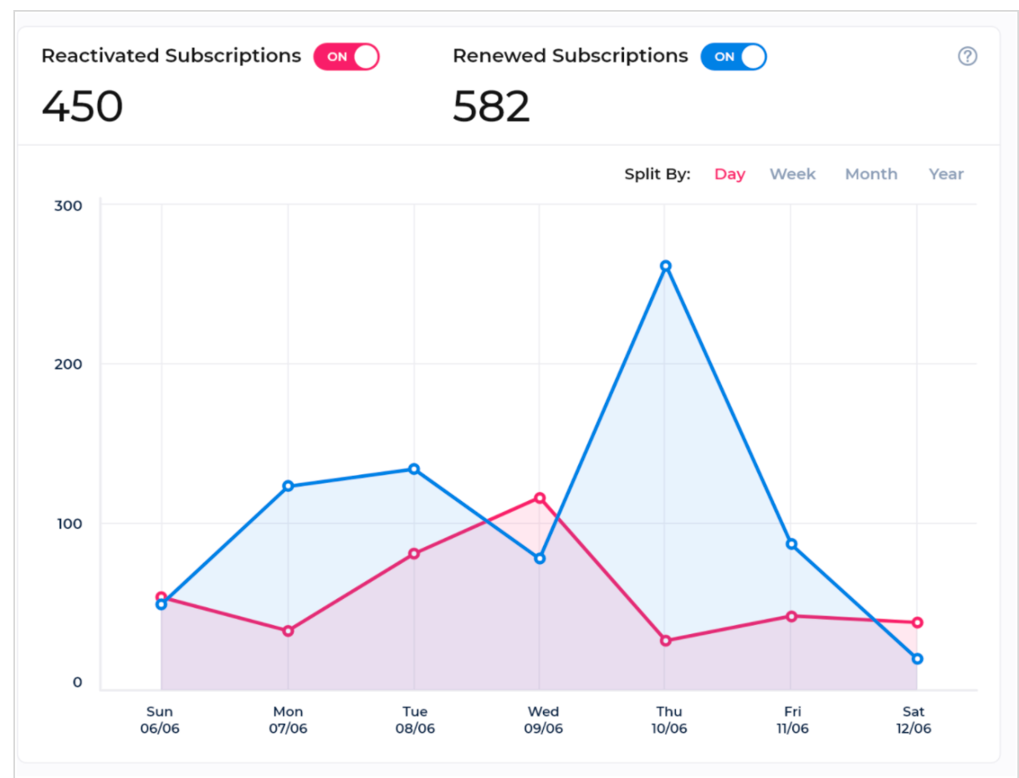

Pay attention to toggles: both of them could be on, one of them could be on or both could be off. When both are off, we don’t show any line charts

Also pay attention to transparency of the line charts. They should be laid to each other when both are on.

You can use dummy data, however, splitting by different periods should work and you should show how dates labels (at the bottom are changing)

For the small icon at the top right - you don’t need to do anything for this task

In case it’s important for you, here is a business logic of the task:

For example, we have a mobile app with a subscription model. Some users are our old users who are just renewing the subscription every month automatically - it’s Renewals (usually much more than new subscriptions and reactivations).

Regarding reactivation. There could be a lot of reasons for reactivation, for example,

user didn’t have money on his card and then he filled it and now he reactivated his subscription after some time of not using our app. This is reactivation.

The column Y is showing the amount of people (0,100, 200). If there are more users in your dummy data, split to bigger amounts of course like 0,500, 1000 etc

Create a test environment to be checked by our Product Manager.

Create a separate github/gitlab/bitbucket repo to push the code and to give for a check to our CTO

*** Before you begin on this task , the above assets and resources are strictly private and confidential. Non-disclosure is required. ***

***After we reviewed , you have to delete every asset and code related to our test. ***